**LAB 06**

**BINOMIAL DISTRIBUTION**

**Aim: To analyze data with Binomial Distribution**

**New-Term:**

1. **dbinom(): This function is used to calculate the probability mass function (PMF) of a binomial distribution. It calculates the probability of getting a specific number of successes in a fixed number of independent Bernoulli trials. In the code, it is used to calculate the probability of getting exactly 2 heads (dbinom(2, n, p)), the probability of getting at least 2 heads (sum(dbinom(2:4, n, p))), and the probability of getting at most 2 heads (sum(dbinom(0:2, n, p))).**
2. **sum(): This function is used to calculate the sum of elements in a vector. In the code, it is used to sum up the probabilities calculated by dbinom() for the at least and at most cases.**
3. **pbinom(): This function is used to calculate the cumulative distribution function (CDF) of a binomial distribution. It calculates the probability of getting up to a certain number of successes in a fixed number of independent Bernoulli trials. In the code, it is used to calculate the probability of getting at most 2 heads (pbinom(2, n, p)).**
4. **weighted.mean(): This function is used to calculate the weighted mean of a vector. In the code, it is used to calculate the expected value (mean) of the binomial distribution (Ex) by taking the weighted mean of the values of x with their corresponding probabilities px.**

**Input:**

**#Fitting probability distribution**

**#Probability of getting a head**

**#Coin is tossed n times**

**n=4**

**n**

**#Probability of getting a head is considered as success**

**p=0.02**

**p**

**#Probability of getting exactly 2 heads**

**dbinom(2,n,p)**

**#Probability of getting at least 2 heads**

**sum(dbinom(2:4,n,p))**

**#Probability of getting at most 2 heads**

**sum(dbinom(0:2,n,p))**

**#or**

**pbinom(2,n,p)**

**dbinom(2,n,p, log = TRUE)**

**pbinom(q,prob,lower.TAIL = TRUE,log.p= FALSE)**

**#Expectations**

**x=0:n**

**px=dbinom(x,n,p)**

**Ex=weighted.mean(x,px)**

**Ex**

**#Variance of x**

**varx = weighted.mean(x*x,px)-(weighted.mean(x,px))^2;**

**varx**

**#Visulisation of probability distribution**

**plot(x,px,type="h",xlab="values of x",ylab="probability of x", main="Binomial Distribution")**

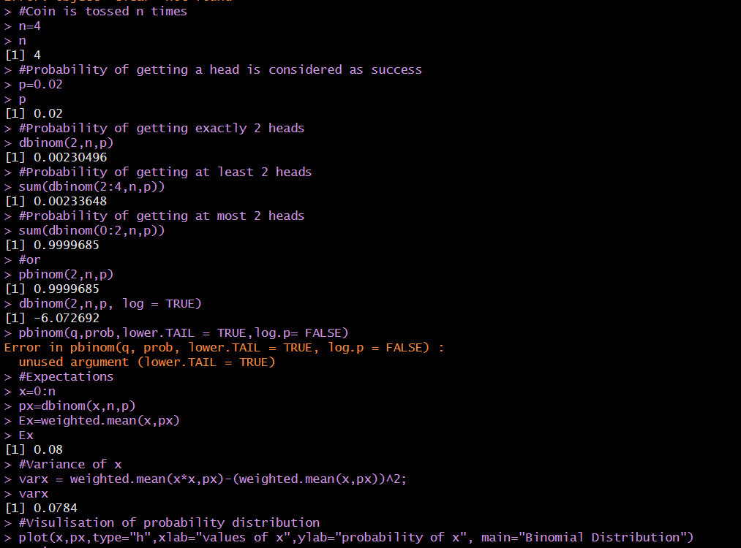**OUTPUT:**

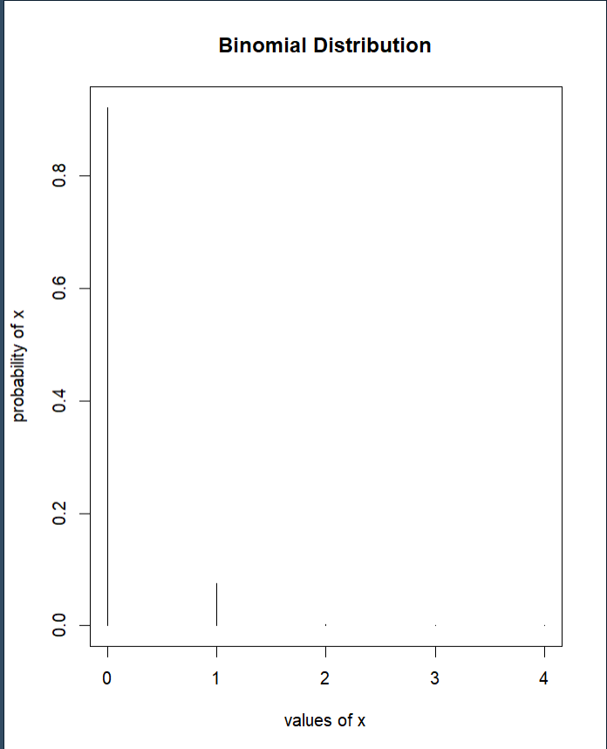

**INFERENCE:  
Variance calculated using weighted mean function and found binomial distribution values for different ranges of a.**